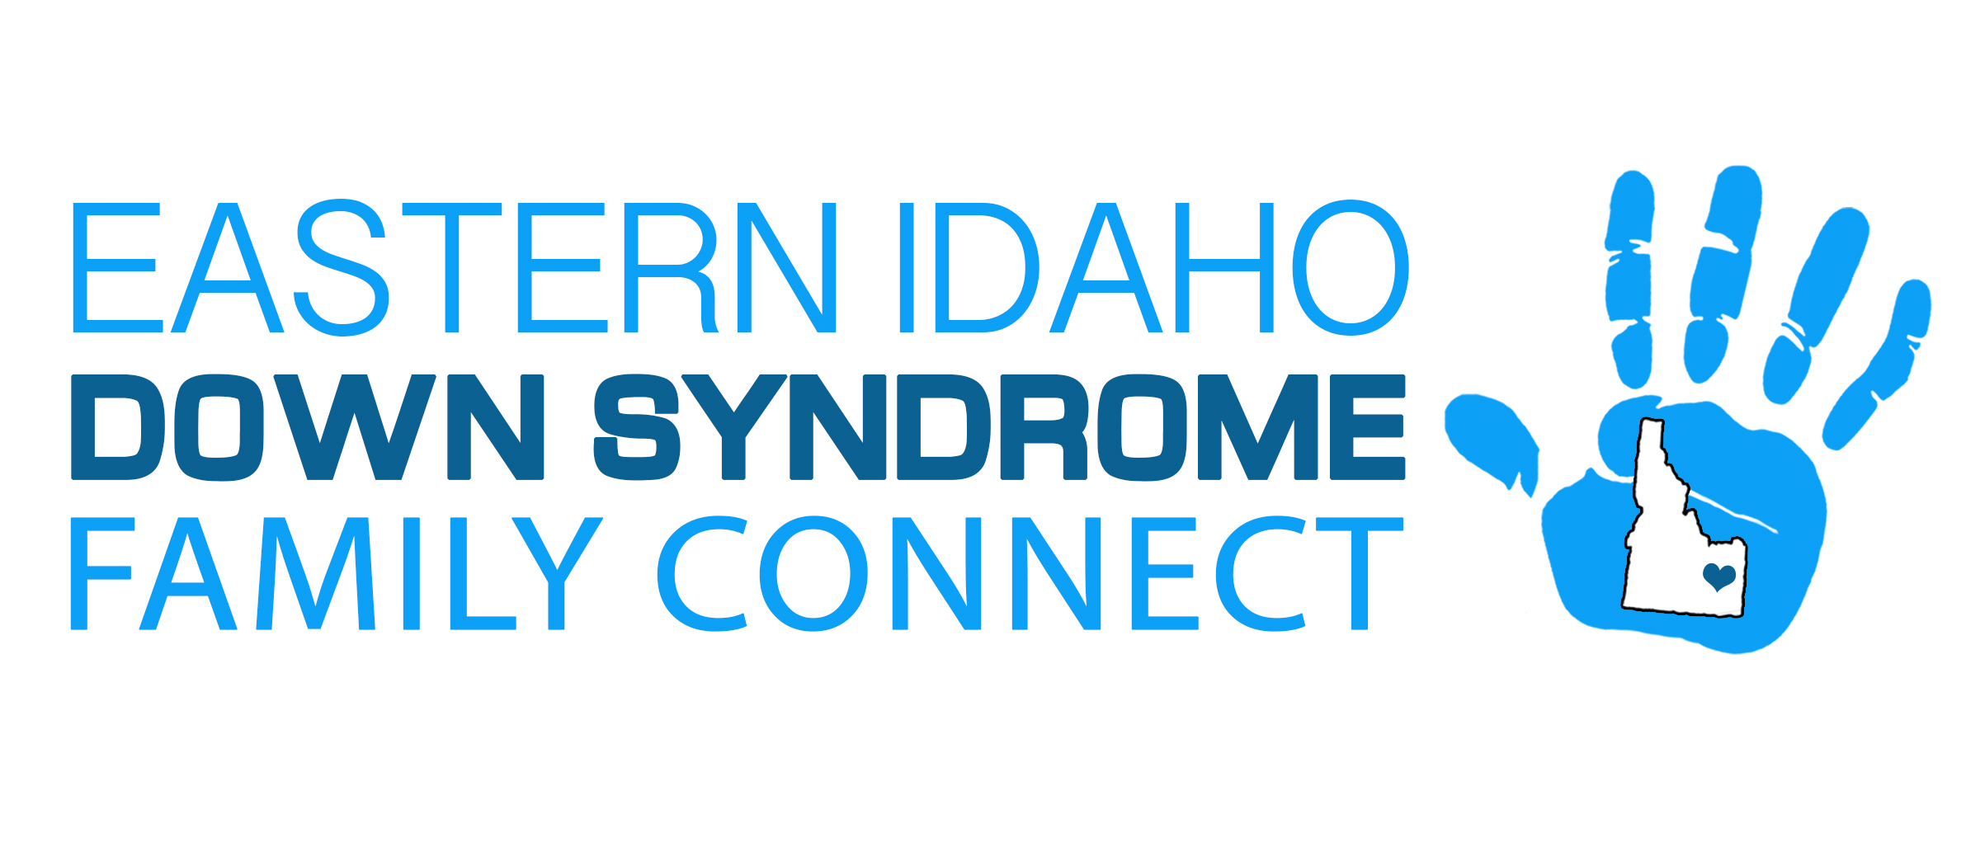
Discontinue Contact Policy
- Policy
It is the policy of EIDSFC to discontinue contacting any person upon that person’s oral or written request directed to the organization, its professional fundraiser, or other agent.
EIDS shall maintain a record of all requests by persons who indicate to EIDS, its professional fundraiser, and other agents, that they do not wish to be contacted by or on behalf of EIDS.
- Limitation:
This policy does not prohibit contact by EIDS that is solicited by a person or a person’s representative, even if the person or his/her representative have requested to be placed on the "do not contact list." Contact by EIDS that is solicited by a person whose name appears on "do not contact" list shall be limited to providing a direct response to the person’s inquiry and shall not cause the person’s name to be removed from the "do not contact" list.
- Procedure
Upon a person’s (or a person’s authorized representative’s) request that EIDS discontinue further contacts, the person’s name and address will be promptly removed from EIDS database or modified to insure that no further contact is made with the person. EIDS will also take steps to insure that the person’s name is removed from any external databases or records under EIDS control.
- Permanent Record
EIDS will maintain a record of all requests for discontinuance of contacts, effective with the adoption of this policy by EIDS board of directors. Oral requests will be recorded in writing by the staff of EIDS and maintained with the written requests. The records of persons who have made such a request will be maintained by EIDS to the extent necessary for legal or liability purposes.
Adopted by majority of the board of directors of Eastern Idaho Down Syndrome Family Connect this [__ day of ______, 20__].
Signed: _____________________________________________________________Secretary - Eastern Idaho Down Syndrome Family Connections

