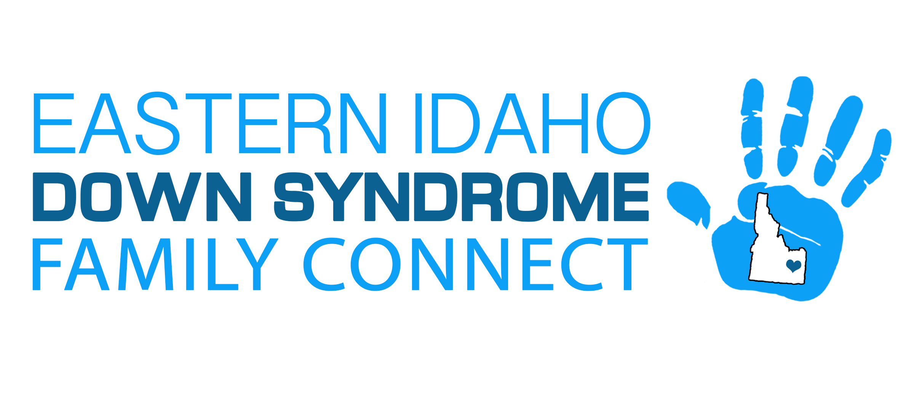
Donor Information Security Guideline
Philosophy
EIDSFC will protect the financial information of donors.
Standard
EIDSFC provides a secure environment for collecting donations and maintains internal controls governing the safekeeping of all confidential donor financial and personal information.
Ensuring a donor’s privacy is vital to the mutual trust between EIDS and a donor. Securing donor financial information helps EIDS build trust by protecting financial information systems and donor financial transactions.
ADDITIONAL INFORMATION
EIDS will also disclose HOW they keep donor information secure through the inclusion of the following within a donor privacy policy.
- • Disclosure of what credit card data is retained by EIDS.
- • Indication to the donor that EIDS (or a third party conducting the transaction) uses secure technology to accept online credit card donations. (This is very often, use of Secure Sockets Layer (SSL) online technology or industry standard security measures and encryption technology by the charity or by a third party.)
- • Reference to the controls placed over physical access to electronically stored credit card information and files.
- • Instructions for users of your website to know how their information is encrypted on the website.
- • Warnings that if EIDS receives credit card information, EIDS cannot absolutely guarantee that the credit card data will be secure, or that EIDS is not liable for information donor shares with others.

