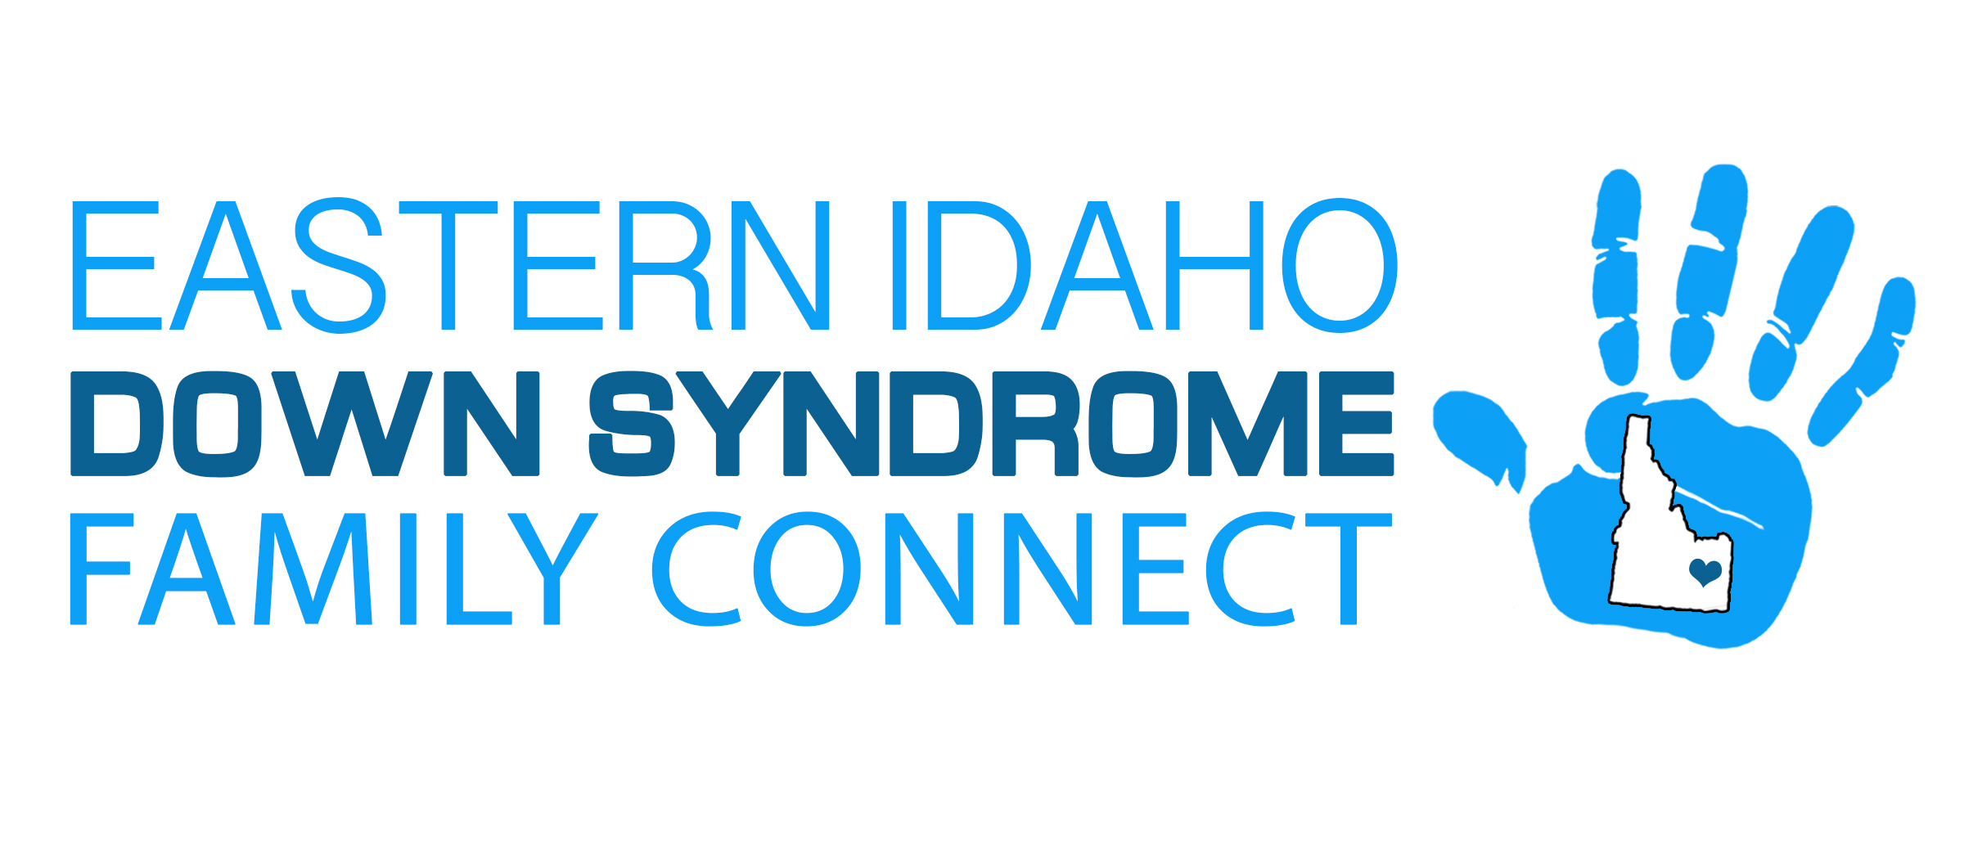
Fundraising Disclosures / Solicitation Checklist
1.) Tax Deductibility Statements for Use in Solicitations and Acknowledgement letters:
“Eastern Idaho Down Syndrome Family Connect is a 501 (c) (3) organization. Your donation will be tax deductible to the fullest extent allowed by the law.
If there was a good or service exchanged as part of the donation, you may need a statement similar to this one:
“Consistent with IRS requirements, we are advising participants in this event that the amount of the contribution deductible for the federal tax purpose is limited to the excess over the value of goods and services received by the donors.
“The amount of your contribution that is eligible for federal tax deduction is (your contribution amount) minus $______________________, the value of the goods or services received in exchange for this donation.
2.) Solicitation Letter Checklist:
- - Name, address, and phone number of Eastern Idaho Down Syndrome Family Connect
Statement attesting to the tax deductibility of contributions
- - A description of the program for which EIDS is seeking support and general description of EIDS purpose.
- - The letter has been examined to ensure that it does not have inaccurate or misleading information.
3.) Donor Gift Receipts Checklist
- - The amount of the contribution that is tax deductible.
- - The date the contribution was received.
- - Name, address, and phone number of the Eastern Idaho Down syndrome Family Connect.

