Minutes—Nov. 4, 2015
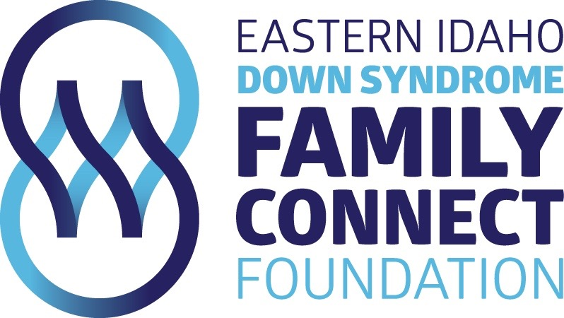

Attending:
Rochelle Larsen
Eric Larsen
Mary Murray
Amy Elison
Karen Hunt

- Someone needs to go to GoDaddy.com to get all the information from Angie Mago. This person needs to create an email account, will talk to Heidi Strickland about possibly doing this.
- Need to check with Heidi Strickland to see if she can figure out what platform (wordpress?) we need to create a donation link on our website.
- Eric Larsen will look into creating a YouTube channel promoting our foundation.
- Amy Elison will create an Instgram account under “EASTIDAHODOWNSYNDROME.” The goal with this is to create positive publicity, inspirational quotes and pictures.
- Rochelle was going to Lana from a local autism group to ask about joining with them at their annual retreat. We decided we could spend between $5000-$6000 to be apart of their retreat.
- We will hold bi-monthly meetings.
- Want to hold a dinner/support meeting in February. Mary was put in charge of coordinating this event.
- Want to have a panel of speakers for our April 2016 meeting. Karen was put in charge of coordinating this event.
- Jaime Jackson was asked to look into quickbooks or another financial record keeping program.

